2017-2018 EDUCATION YEAR TİCARET ODASI PRIMARY SCHOOL 2nd TERM
2nd ENGLISH WRITTEN EXAM OF 4th GRADES
Name & Surname : ____________________________________ Number:_________ Class: 4/A


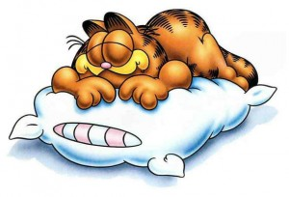

A.Choose the correct answer ( 25x 4=100points)
He is lazy

1)

A) She’s friendly. |  | B) She is bald.
 | C) She’s lazy. |  | D) She is hardworking.

2) What is he like?
A) He is friendly. B)He is tall.
C)He is shy. D)He is fat.

3) Aşağıda verilen bilgilere göre Efe’nin babası hangi görseldedir?

A)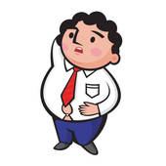B) C)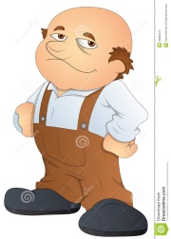 D)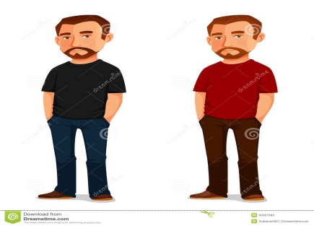

4) Görsele uygun cümleyi seçiniz.

- She has got short blonde hair and green eyes.
She is short and fat.
- She has got short brown hair and blue eyes.
She’s tall and slim.
C) She has got long straight blonde hair and
brown eyes. She is short and heavy.
D) She has got wavy brown hair and green eyes.
She’s ugly and fat.

5)

Görselin yanındaki cevabı verebilmemiz için hangi soruyu sormalıyız?

A) What is his job?
B) Where does he work?
C) What does he look like?
D) What is he like?
6)

A) long B) straight
C) curly D) white

7) Yandaki görselde
işaretlenen bayanı
tanımlayan cümle
hangisidir?

A) She is short. B)She is tall.
C) She is fat. D)She is of medium height.

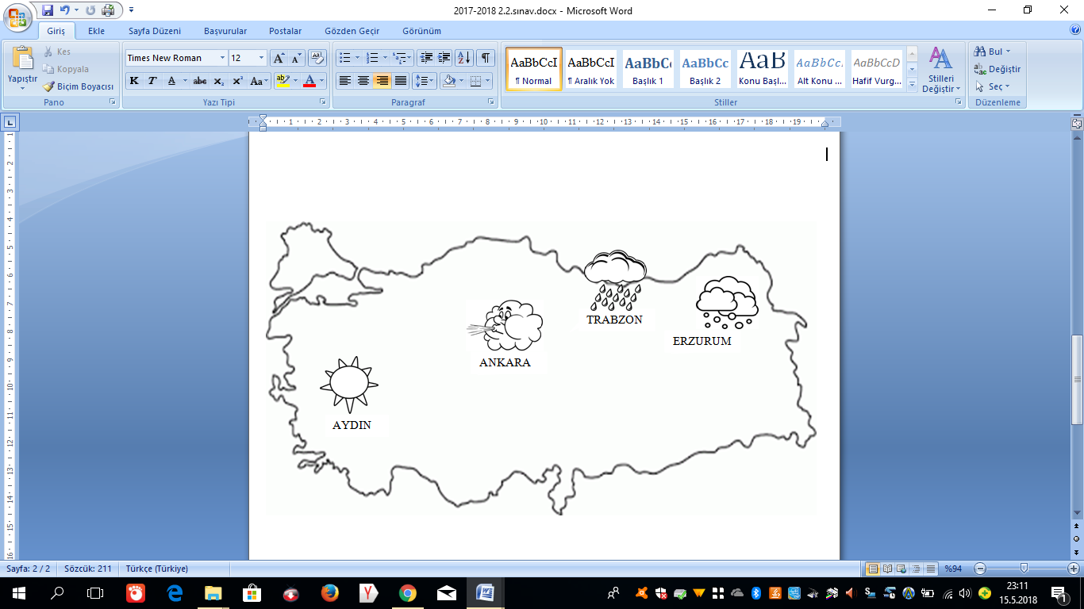
8,9,10 ve 11. soruları yukarıdaki görsele göre cevaplayın.

8) What is the weather like in AYDIN? It's...

A) sunny B) windy C) rainy D) snowy

9) What is the weather like in ANKARA? It's...

A) foggy B) windy C) rainy D) snowy

10) What is the weather like in TRABZON? It's...

A) sunny B) thundery C) rainy D) snowy

11) What is the weather like in ERZURUM? It's...

A) sunny B) windy C) rainy D) snowy

12) It is March . What season is it? It's...

A) It is summer B) It is winter
C) It is autumn D) It is spring.

13)

Boşluğa hangi ay adı yazılmalıdır?
A) January B) October C) June D) May
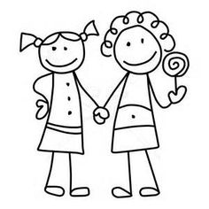
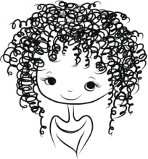

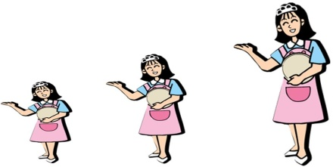

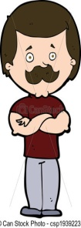

September - ????? - November - December

20) How many SEASONS are there in a year?

A) 12 B) 4 C) 8 D) 365

21) How many MONTHS are there in a year?

A) 12 B) 4 C) 8 D) 365

22)

23)

24) Görseldeki kişi aşağıdaki soruyu nasıl cevaplamış olabilir?

A) It's cold and snowy.
B) It's hot and sunny
C) It's warm and rainy
D)It's cool and windy.

25) Aşağıdaki resim-kelime eşleştirmelerinden hangisi yanlıştır?
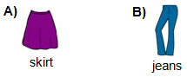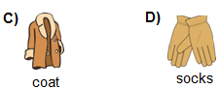

GOOD LUCK!
14) Aşağıdaki tablolar eşleştirildiğinde hangi sonuç ortaya çıkar?

1 | pilot
2 | vet
3 | farmer

a | milk cows
b | help animals
c | Fly planes

15) Aşağıdaki boşlukları sırasıyla hangi seçenekteki bilgiler ile doldurmalıyız?
1. A doctor works at a ..........
2. A policeman works at a.......
3.A chef works at a ......

A) hospital , farm , restaurant
B) hospital , police station , restaurant
C) school , fire station , farm
D) theatre , restaurant , school

16) Yandaki görsele
hangi soru sorulmuş
olabilir?

17) . Aşağıda resimleri verilen kıyafetlerin isimlerinin bulunduğu seçeneği işaretleyiniz.
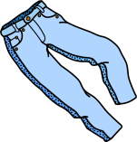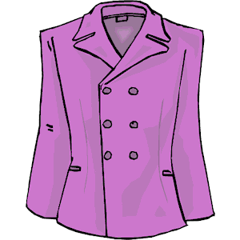

A) jeans-coat –shoes- scarf | B) shorts-shirt-boots-hat
C) jeans-jacket-shoes-hat | D) jeans-skirt-shoes-coat

18)

Yukarıdaki cümleye aşağıdakilerden hangisi YAZILAMAZ?
A) sunglasses B) shorts
C) T-shirt D) boots

19) What are the months of SUMMER?

A) June , July , August
B) March , April , May
C) January , February , March
D) December , January , February

A) 1-c , 2-a , 3-b
B) 1-a , 2-c , 3-b
C) 1-c , 2-b , 3-a
D) 1-b , 2-a , 3- c

It's rainy .Take your ...........

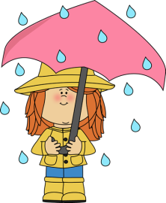
A) sunglasses
B) hat
C) skirt
D)umbrella

?
May I borrow your
sunglasses?

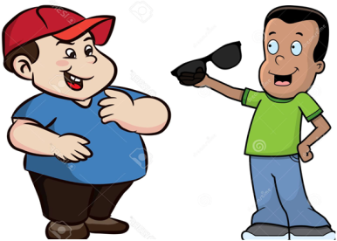
Soru işareti yerine aşağıdakilerden hangisini söylemiştir?

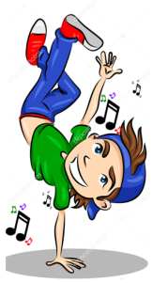
I'm a dancer

A)What is your job?
B) Where do you work?
C) What do you like?
D) What is he like?

A) I'm sorry , it is broken.
B) Sorry , I need it.
C)Here you are.
D) I'm sorry ,not right now.

?
What is the weather like in WINTER?

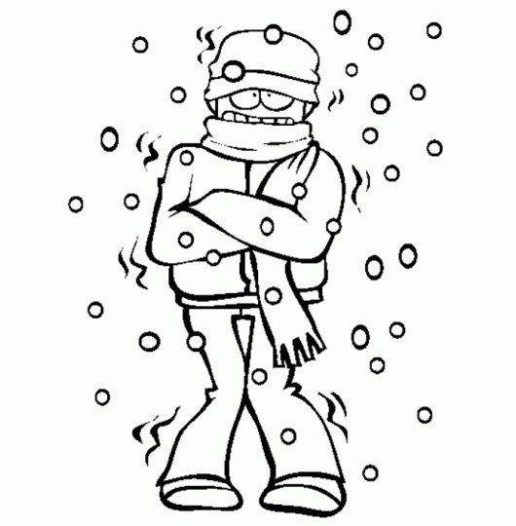

I need .....in summer.

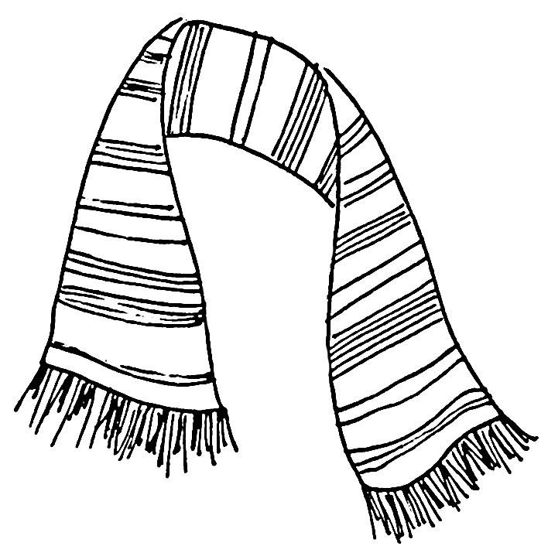
scarf

