5. SINIF 2 DÖNEM 1. YAZILIYA HAZIRLIK KAĞIDI _ 142 SORU
___ 1.What kind of movies do you like? a.It is at 2:30 ___1. When is your birthday? A. You are welcome.
___ 2.What is the movie about? b. It is about adventure. ___2. Do you like balloons? B. It is on 11th April.
___ 3.What is your favorite movie? c. I like comedy movies. ___ 3. Can I have my party at home? C. Of course, you can.
___4.What time is the movie? d. It is Hababam Sınıfı. ___ 4. Do you need a birthday cake? D. Yes,I do.
___5.Do you like horror films? e. No, I don’t . ___5. Thank you very much. E. No, we have a cake.

1. I don’t like Garfield because he is lazy / friendly. clown evil beautiful brave helpful strong ugly
2. I like Keloğlan because he is friendly / evil 1. The witch is __________________ 5. I don’t like Susan. She is ___________
3. Pinocchio isn’t honest / brave. 2. The girl is ____________________ 6. Mehmet can carry five boxes.
4. I hate Gargamel because he is funny / evil 3. The soldier is ________________ He is _______________.
5.Superman is a lazy / strong character. 4. The gentleman is ______________ 7. He is a _______________.
6. Balkız is helpful / boring.

1. Enis: Can I answer the question? invitation card - birthday cake - candles - balloons - gift





Teacher: …………………………..
a) Thank you very much.
b) Of course you can.
2.Sıla: ……………………………….. Yağmur: Not right now _________ __________ __________ ________ _________
a) Can I use your English book? 1. I have a toothache a. You should take an aspirin. (……………)
b) See you soon. 2. I have a sore throat. b. You shouldn’t eat chocolate. (……………)
3. Mert: Thank you very much. 3. I feel cold. c. You shouldn’t lift heavy things. (……………)
Ömer: ………………………….. 4. I have a headache. d. You shouldn’t drink cold water. (……………)
a) You’re welcome b. Sure 5. I have a backache e. You should get a blanket. (……………)
4. İrem: Take care. Farklı olanı işaretleyiniz 1. JANUARY 7. JULY
Zuhal: ………………………… 1. Monday - September - August - March 2. ____________ 8. _____________
a) Bye. b) Can I open the window? 2. science fiction - adventure - comedy - watch 3. MARCH 9. _____________
5. Yunus Emre: Can I play? 3. Sunday - April - Wednesday - Friday 4. A______ 10. ____________
Nejdet: …………………… . 4. toothache - fever - doctor - cold 5. ___________ 11. N___________
a) No ,you can’t b) See you at school. 5. gift - clown - balloon - cat 6. JUNE 12. ____________

toothache headache stomachache broken leg backache the measles
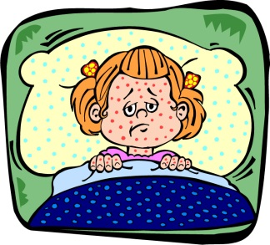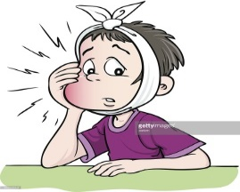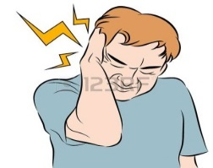
________ ________ _________ __________ _________ _________
eye nose mouth ear head
hand finger knee leg foot *movie *science fiction * exciting *what

A:Do you like watching films?
nne

_
_ _
_ _

_ _
_

_

_
B:Yes, I love going to the cinema.
A:_____________ is your favourite film?
B:It is Transformers.It is a / an ___________ movie.
A:What is the ____________ about?
B:It is about cars.
A:What do you think of the movie?
B:I think It is __________.

animation - action - news - comedy - horror - love story

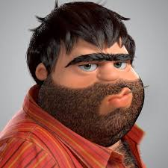
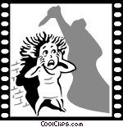

________ ________ __________


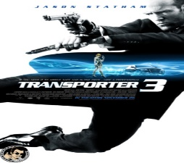

1.I don’t like horror films.I think they are _____________
a)frightening b)funny c)boring d)interesting
2.The film starts at 4:30.
a. two o ‘clock b.four o’clock c.half past four d.quarter past four
3.A:I have a runny nose .
B:You should buy some ____________.
a.cough syrup b. tissues c. blanket d. Candies __________ _________ _______
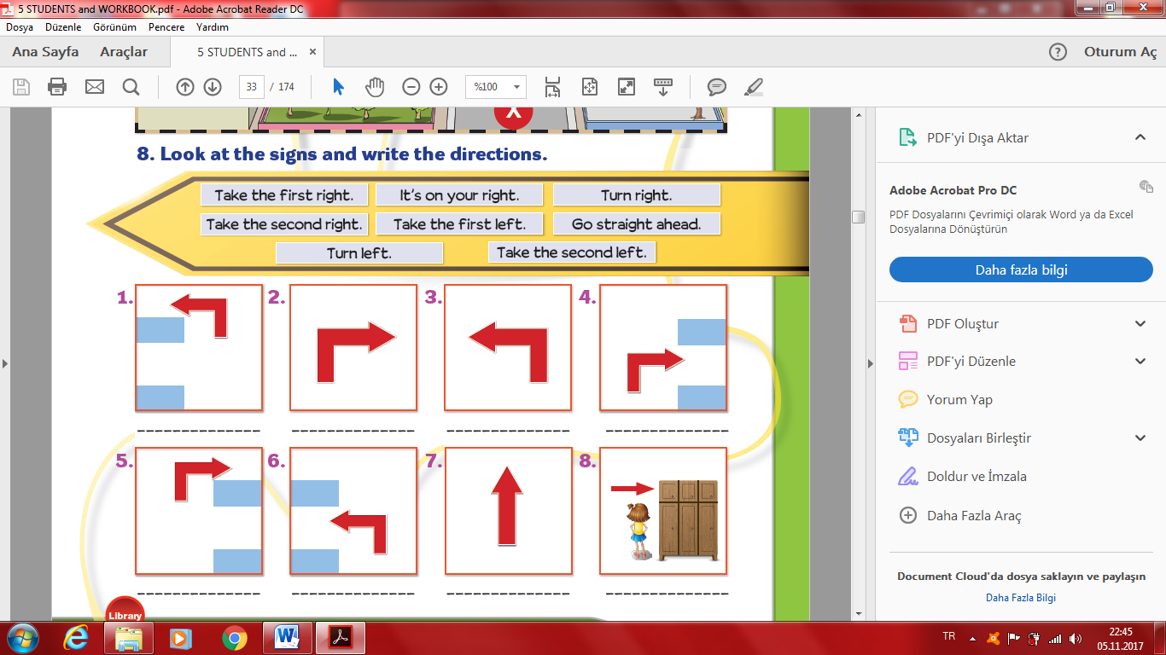
cafe pharmacy pool
playground bookshop
1. It is summer. I can swim in the ____________
2. I like reading books. I can buy some books from the ___________.
3. I love coffee and cookies. Where is the ___________?
4. Excuse me, where is the ___________? I need some aspirins.
5. The children can play in the ___________.

____ Go straight ahead. ____ Take the first right. ___It is on your right. ___Turn left.
___ Take the second left. ____ Take the second right. ___Turn right. __Take the first left.

1. "It is a board game. You need two players. " A) Hide and seek B) Blind man’s buff C) Chess D) Tag
2.My favourite lesson is - - - - . A) Art B) Physical Education C) Social Studies D) Science
3. Ali :…………? Berra : At 7:30. A) Where are you from B) Do you like listening to music
C) What time do you get up D) How old is your father
4. Hello. I am Stephen. I am from England. I speak - - - - . A) Spanish B) Russian C) Turkish D) English
Geography / ICT / Maths / English / Music / Art / Science / Physical Education / History /Turkish
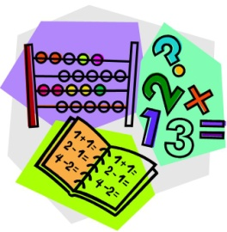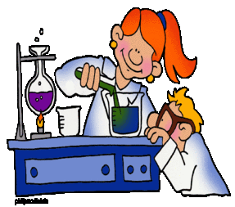
____________ /________ _/________ _ _ _/______ __ _ _/___ _____
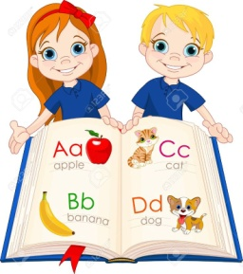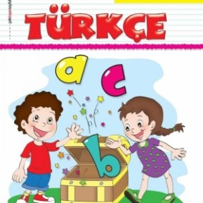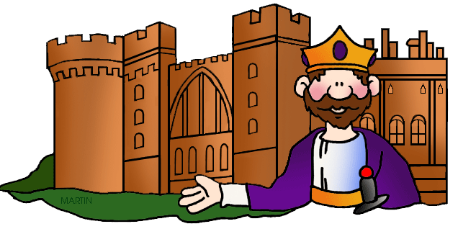
__________ __ /_____ ___ __/____ ___ __ _/___ ___ ___ _/__ _ _____

horror / cartoon / sci-fi / comedy / animation
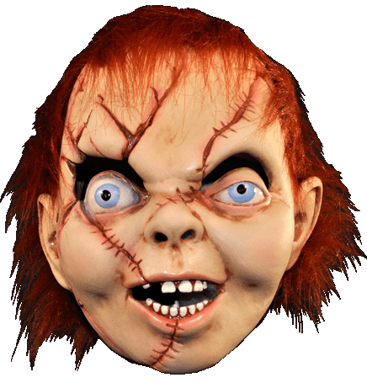
.......................... .......................... ............................ .................................. ...........................

COUNTRY | NATIONALITY | COUNTRY | NATIONALITY
Turkey | Turkish | ……………… | Japanese
……………… | Italian | Germany | ………………
Russia | ……………… | ……………… | French
......... 1- Do you like cartoons? a) It is at eight o’clock.
........ 2-What's your favourite film? b) No, I don't.
........ 3-What's the movie about? c) It is "Düğün Dernek".
......... 4-What time is the movie? d) I have stomachache.
......... 5-What's the matter with you? e) It's about a cat and a mouse.

birthday cake / party / invitation / decorate / guest 1. Jane : Can I come in?
1. We should ..................................... the party room with balloons. Teacher : - - - -. Come in, please.
2. Who are coming to the party? Let's prepare a ............................. list. A) Not right now B) No, you can’t
3. My friend is organizing a fancy dress .......................................... . C) Yes, of course D) Wait a minute
4. The ................................. is very delicious. 2. Bill : Let’s go shopping.
5. We must prepare ............................... cards for my birthday party. Sandra : - - - -. I must go to the doctor now.
Types of movies | The movie is about … | I think it is …..
A) I’m busy then B) Yes, you can
C) Yes, of course D) I’m sorry, I can’t
3. I - - - - for my birthday party.
A) visit the dentist B) decorate my room
C) take some medicine D) do my homework
4. The month before March is - - - -.
A) January B) May C) April D) February
5. Please join my 10th birthday party
Place : My house Date : 11th April Sunday
*cars *action *animals *boring Time : 15:00 Sender : Selim
*animation *drama *funny *exciting >> Where is the party ?
* comedy *a professor and a dog a. 15:00 b. On Sunday c. 10th d. Selim’s house

