7.2.1 YAZILIYA HAZIRLIK KAĞIDI _ farklı türlerde 155 soru
An evil eye bead is one of the symbolic images in Anatolia. Wherever you go in Turkey, it’s possible to see evil eye beads. For example; if people buy a new car, they need to take an evil eye bead in the car; they think that they won’t have a traffic accident. If people want to visit a new born baby, his/her parents usually put an evil eye bead on him/her to protect him from evil eyes. I think Turkish people believe superstitions strongly, and carrying an evil eye bead on you means it will protect you from bad things like the evil eye.
1. Evil eye bead is a religious obligation in Turkey. T / F 4.When people get a new car, they take an evil eye bead in the car. T / F
2. If there is an evil eye bead in the car, you have an accident. T / F
3.There is usually an evil eye bead on a new born baby. T / F 5. An evil eye bead protects you against the evil eye. T / F
Order the words to make meaningful sentences.
1.rain / think / will / soon / it / I (.) ...............................................................................................................................
2. have to/ the school / We / obey / rules (.) ...............................................................................................................................
3. don’t / the school trip/ attend / you / Why (?) ...............................................................................................................................
4. invite / Let’s / to / all students / the party (!) ...............................................................................................................................
5. abroad / want / I / study / to (.) ...............................................................................................................................
6. will / sure / I / rich / be / he / am / very (.) ...............................................................................................................................
7. superstitions / I / believe / never (.) ...............................................................................................................................
8. have / We / in / clean / won’t / enough / the future / water (.) ....................................................................................................................
9. will / Robots / the housework / do (.) ............................................................................................................................. …………………………….

join send order attend buy wear accept check
1. ....................... my invitation, please. I would like to see you there. 5. ............... your mails every day.
2. ....................... an invitation card to Berke. 6. .................. the soup before main course, please.I’m hungry.
3. ...................... your cap and gown; it’s your graduation ceremony. 7. ................. to the meeting. It’s very important.
4. ...................... us at the café, everybody will be there. 8. .................. a few colorful party hats for the party.

Fill in the blanks >> Couch potato boring fortune telling present educational
1.Today is my brother’s birthday. I should buy a _____________ for him. 4. I don’t believe _______________ because it is nonsense.
2. I prefer watching documentaries because I think they are ________. 5. My father is a ___________. He always watches TV all day.
3.I don’t like watching soap operas because I think they are _________________________.
Choose the correct answer
1) Is there some/any water in the glass? 3) There are a few/a little students in class. 5) I have got many/a little money
2) Would you like to drink some/any tea? 4) There aren’t much/many books here 6) There is an/a lot of oil in the bottle

‘‘How much’’ or ‘‘How many’’ 1)……………………….…..….. days are there in a week? 3) ………………………………... money have you got?
2)……………………………….. cheese do you eat in a day? 4)………………………..……..…. girls are there at school?

Match the questions and answers. Send –order –buy –ask- decorate
1. Where do you live? …. A. Mark ______________ room
2. Who has got a fancy dress party? …. B. Pumpkin, candies, candles ________________ cake
3. What do you need for a Halloween party? ….. C. Because I was ill _______________ beverages
4. What time does Survivor start? ….. D. in Amasya ____________ invitation cards
5. Why weren’t you at school yesterday? …… E. at 8. P.m _____________ permission from parents

What about – Why don’t– Let’s – should - Would you like 3.__________________________ giving a surprise party?
1.__________________________ we arrange the music? 4.________________________ prepare a lot of food.
2. We_________________ write invitation cards 5. _______________________to join my pyjamas party?

GOOD LUCK BAD LUCK a) Breaking mirror Fill in the blanks with ” a / an / some / any.”
b) Walking under a ladder 1.Would you like ____________________ tea?
c) Finding a four leaf clover 2. Do you need ...................................................... help?
d) Seeing a black cat 3. She wants to buy ........................ big house.
e) Hanging a horseshoe over a door 4. If you want to make orange juice,take .......................... oranges
f) Opening an umbrella indoors 5. We need .......................................... decorations for the party.

Hi,I’m Bill. In my town there are lots of superstitions. I don’t believe them. Many people in my town are superstitious.For example,they think broken mirror brings bad luck. A horseshoe brings good luck. Number 13 means bad luck. Opening an umbrella indoors brings bad luck. Cutting nails at night also brings bad luck.Some people believe white rabbit and four-leaf clover bring good luck.
1. If you break a mirror,it brings good luck. ……… 3. Many people in Bill’s town are superstitious. ………
2. Bill is superstitious. ………………… 4. Number 13 brings bad luck. …………
Match the sentences. a. School b. Pharmacy c. Zoo
......... 1) We haven’t got any food in the fridge. A) I’ll help her. d. Fire station e. mosque
......... 2) I’m too tired. B) I’ll go swimming with my friends. 1.You can see a lot of wild and domestic
......... 3) It is too hot today. C) I’ll sleep early today. animals there. _____
......... 4) It isn’t late. D) I’ll go to the supermarket. 2. You can buy medicine there. _________
……… 5) My mother has a lot of things to do. E) I won’t get a taxi. I’ll walk. 3. If you are a Muslim, you pray there. ____

___ 1. If you open an umbrella indoors, A- it will bring a bad luck. 4. You usually go there on weekdays
___ 2. If you find four leaf clover, B- it will protect you against the evil eye. and you get education there. _____
___ 3- If you wear a blue bead, C- it will bring seven years bad luck . 5. If you see a fire, who will you call
___ 4- If you break a mirror, D- it will bring a good luck immediately? ____
___ 5- If your right hand itches, E- you will get money.
Hi, Mike. I’m going out to buy a present for Alice. Please help me with the arrangements. First, prepare some snacks. We need some beverages. Buy some cold drinks from the market. Don’t forget to take the cake from the bakery. The party will be crowded so we need a lot of plates and glasses. Finally take everything to the Rainbow Cafe and check the decorations. The party starts at 14.30 so please get ready until 14.00. Thanks for your help.
1. Whose party is it? 4.Do they need any cold drinks?
2. Where is the party? 5. What is Flora going to buy?
3. What time does the party start?
“ why don’t you, let’s, how/what about, shall we, should” 3. ............................................................... invite all our friends?
1. A:............................ throw a fancy dress party this weeked. 4. ............................................................ buy the birthday cake?
2. A: ............................................arranging the music? 5. We ........................................ buy some sandwiches and cookies.
MATCH THE SENTENCES
1
2
3
4
5
6
7
8
9
10
1-Who are you arranging a surprise party for? A. Depends on the weather.It is usually rainy.
2-Would you like to go to a pyjama party? B. I’m sorry,I can’t.I am very tired.
3-Let’s have an outdoor party! C. )that’s not a good idea .I don’t like board games
4-What about playing backgammon? D. Yes,let’s.We can cook lasagne.
5-Would you like to go shopping? E. Not more than 10.Just my close friends.
6-Let’s invite some friends! F. Sure!Where is the party?
7-How many friends do you want to invite? G. Let’s make a shopping list.
8-Would you like to come to Ali’s graduation party? H. My sister.
9-What do we need for the dinner? İ. Of course!I love fruit.
10-Would you like some strawberries? J. I am afraid,I can’t.I have alot of work to do.

READ THE PARAGRAPH AND STATE TRUE OR FALSE
Emily has some superstitions. She believes that number 5 brings good luck to her. When she travels to another city she prefers buying number 5 seat on the plane because she thinks she will have a safe flight. Emily has also a lucky object. If she has an important business meeting,she wears her blue scarf. She forgot to wear it for the meeting last Monday and she failed to get the job. When she returned home, she was unhappy and she promised herself not to forget it again.
1-Emily is not a superstitious person. T / F 4- She thinks she will have an accident at number 5 seat. T / F
2-She got the job because she didn’t forget her blue scarf. T / F 5- She likes wearing her blue scarf. T / F
3-She didn’wear her blue scarf last Monday. T / F
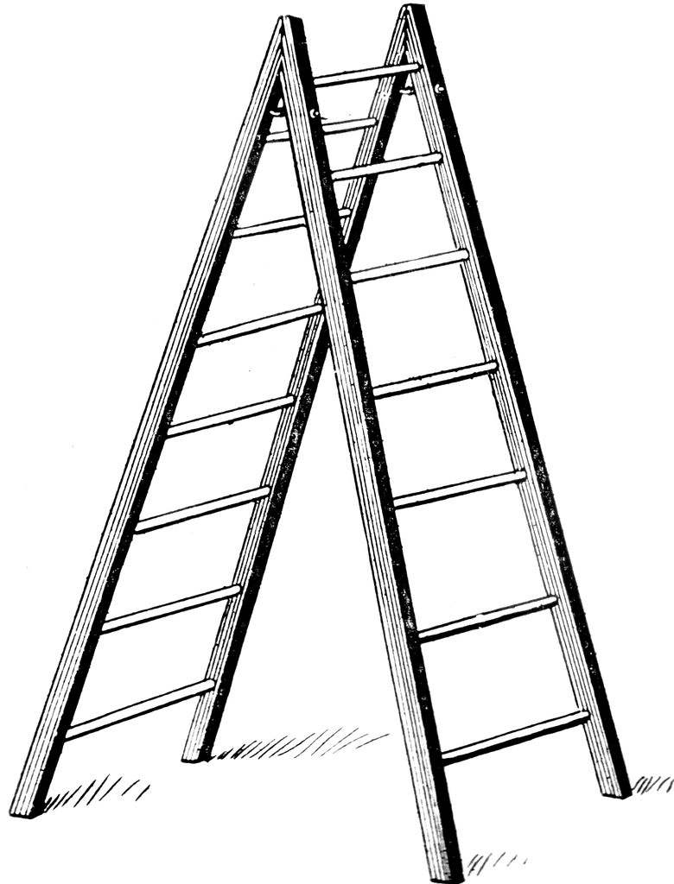
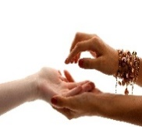



a. four leaf clover
b. Fortune teller
c. Palm reading
d. evil eye bead
_____ ____ _______ _______ ______ e. gift
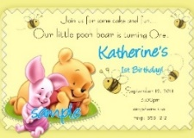
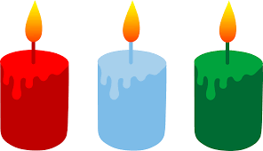


f. Ladder

g. Broken Mirror
h. Candles
i. beverages
j. invitation card
___ ____ ____ ________ ____

1
2
3
4
5
6
7
8
9
10

1. Good luck a. şanslı Put the verbs in the gaps according to IF CLAUSE TYPE 1
2. Bad luck b. Tahtaya vurmak 1. If they ______________ (earn) enough money, they ______________ (go) to
3. Unlucky c. Nazar boncuğu France for their holiday this summer.
4. Lucky d. Davet etmek 2. If Simon _____________ (catch) a fish today, we ________________ (eat) it.
5. Blue bead e. Falcı 3. She ______________ (buy) a Porsche if she ______________ (win) the lottery.
6. Palm reading f. Şanssız 4. If it ______________ (rain) in the Sahara desert, everyone __________ (be)
7. Touch wood g. İnanmak very surprised.
8. Fortune teller h. iyi şans 5. You ______________ (become) fat if you _____________ (eat) too much.
9. Invite i. El falı
10. Believe j. Kötü şans

Match the questions with their anwsers Türkçelerini yazınız
___1.How much butter do you need for the cake? A. I’ll wear a witch costume leaving scissors open
___2.When is your birthday? B. Ten empty buckets
___3.What will you wear at fancy dress party? C. Once a week palm reading
___4.How many books will you buy ? D. A little, please a shooting star
___5.How often do you go to cinema? E. On third of May, 1981 beverages
Circle the right option barbecue party
Do you have a lucky number ? Yes, it is green/five/my pencil go shopping
Do you have a lucky object ? Yes, it is green/five/my pencil party decorations
Do you have a lucky colour ? Yes, it is green/five/my pencil fortune teller
What do you do when you see a black cat ? I feel nervous / I watch TV horoscopes
What do you do when you break a mirror ? I go to school / I feel unlucky superstition
Do you like coffe reading ? Yes, I do / I drink tea evil-eye

