7.sınıf İngilizce deneme

1-) İbrahim prefers ................. football
to ..................... music.
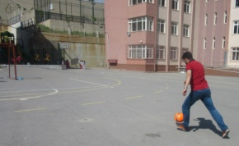
a) playing / listening to
b) play / listen to
c) played / listened to
d) plays / listening to
-----------------------------------------------------

2. ve 3. soruları aşağıdaki bilgilere göre cevaplayınız

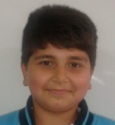
BERAT AHMET JONAS
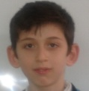
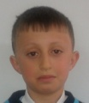

52 kg 63 kg 58 kg
155 cm 170 cm 165 cm
12 years old 14 years old 13 years old
2-) Which sentence is false?
a) Berat is the slimmest of the three.
b) Ahmet is the youngest of the three.
c) Berat is shorter than Ahmet.
d) Jonas is older than Berat
-----------------------------------------------------3-) Which sentence is true?
a) Jonas is the fattest of the three.
b) Berat is taller than Ahmet
c) Ahmet is slimmer than Jonas
d) Berat is the shortest of the three.
-----------------------------------------------------

4-) ...............................................................
to stop extinctions!
a) We must buy pets
b) We mustn’t overkill / overhunt wild animals
c) We must wear fur and destroy nests.
d) We mustn’t build a birdhouse in the garden
-----------------------------------------------------
5-) Exhaust gases pollute the air and environment. So, people must use ....................
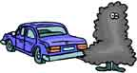
a) electronic devices b) pesticides
c) public transportation d) bottles

6-) There are the ............. , eight .............
and a lot of .................. in the solar system.
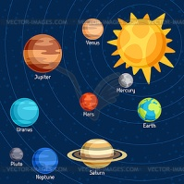
a) Sun – planets - comets
b) Moon – stars - astroids
c) Earth – Suns - satellites
d) Sun – astroids - comets
-----------------------------------------------------7-) We ................ save water.
So, ............. let water run while brushing teeth
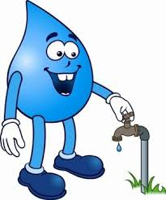
a) must / don’t b) can’t / should
c) won’t / must d) shouldn’t / doesn’t
-----------------------------------------------------
8-) Which one is not a superstition?
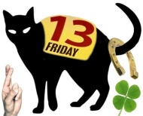
a) Finding a four-leaf clover
b) Hanging an umbrella
c) Cutting nails at night
d) Breaking a mirror
-----------------------------------------------------
9-) He ........... a dentist ten years ago ,

but he ............ a waiter now.

a) is / was b) were / is
c) was / is d) was / are
-----------------------------------------------------
10-) İrem: The English exam was too difficult.
Hilal: .....................................
I think it was very easy!

a) I don’t agree with you b) OK.
c) Yes, it was. d) Great idea!
-----------------------------------------------------

