Name / Surname
Class
Number


……………………………………………………… İLKOKULU MÜDÜRLÜĞÜ
2017-2018 EĞİTİM-ÖĞRETİM YILI - İNGİLİZCE DERSİ
4. SINIFLAR - II. YARIYIL I. YAZILI YOKLAMA

A) Aşağıda cevap cümlelerini görsele uygun olacak şekilde tamamlayınız. (10x2=20 points)

ruler / school bag / bottle / book / pencil


What is this in English? What is this in English? What is this in English? What is this in English? What is this in English?

It's a ............................ It's a ........................ It's a ......................... It's a .......................... It's a ............................

glass / container / eraser / microscope / test tube

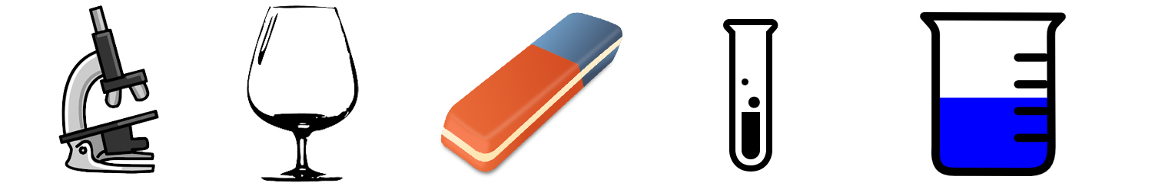

What is this in English? What is this in English? What is this in English? What is this in English? What is this in English?

It's a ............................ It's a ........................ It's a ......................... It's a .......................... It's a ............................

B) Aşağıda verilen görselleri ilgili oldukları ifade ile eşleştiriniz. (5x4=20 points)

in / near / under / on / in front of

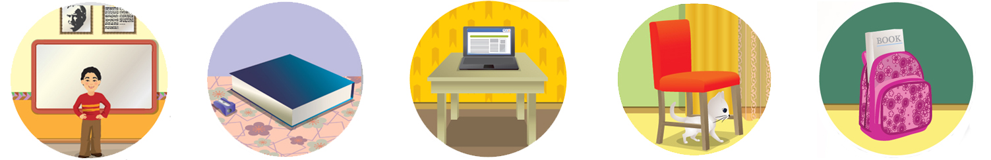
Where is the student? Where is the pencil sharpener? Where is the laptop? Where is the cat? Where is the book?

He is It is It is It is It is
............................ ............................ ............................ ............................ ............................
the blackboard. the book. the table. the chair. school bag.

C) Aşağıda cümlelerin "true" (doğru) ya da "false" (yanlış) olduklarını yanlarına yazınız. (5x2=10 points)

............. 1- Mix red and white, you get pink. ............. 4- Mix red and yellow, you get blue.

............. 2- Mix red and blue, you get black. ............. 5- Mix black and white, you get grey.

............. 3- Mix yellow and blue, you get green.

D) Aşağıdaki boşluklara resme uygun "meslek" adlarını yazınız. (12x2=24 points)

fireman / nurse / doctor / policeman / student / writer

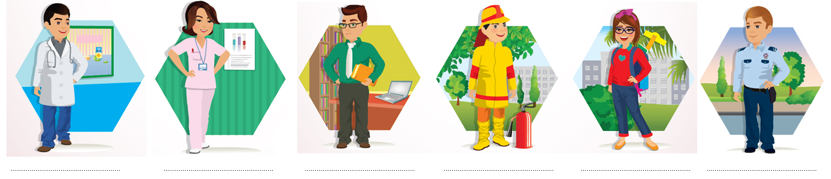

policewoman / teacher / dancer / pilot / farmer / chef

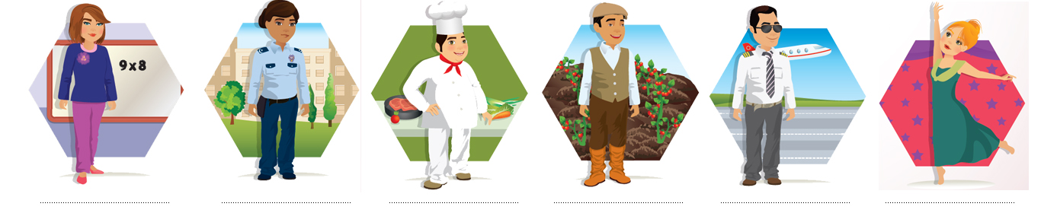

E) Aşağıda verilen meslek grupları ile çalıştıkları yerleri eşleştiriniz. (7x2=14 points)

........ 1- policeman a) school

........ 2- teacher b) restaurant

........ 3- farmer c) hospital

........ 4- fireman d) airport

........ 5- chef e) police station

........ 6- pilot f) firestation

........ 7- doctor g) farm

F) Aşağıdaki görevleri yerine getiren meslek gruplarını bulmacadan bulup daire içine alınız. (6x2=12 points)

serve food / help patients / milk cows / help animals / fly planes / teach children

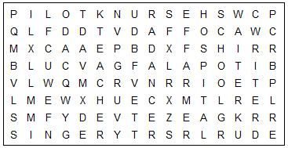



....................... .............................
Teacher of English Deputy Head
The exam is forty minutes.
GOOD LUCK!

